### Password Self-Reset

Users who have forgotten their password may perform a self-reset using the **Forgot your password?** link on the login page. After clicking this link, the user will be taken to the screen below.

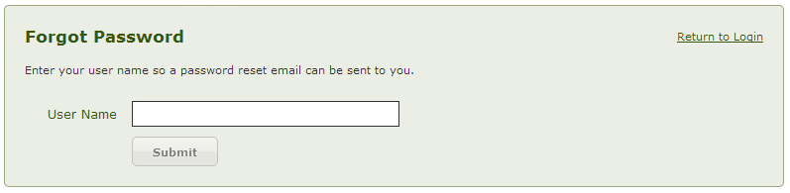

After submitting a valid user name, a reset email will be sent to the user.

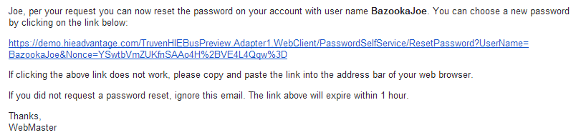

Clicking the link within the email will take the user to a screen to answer a security question and create a new password.

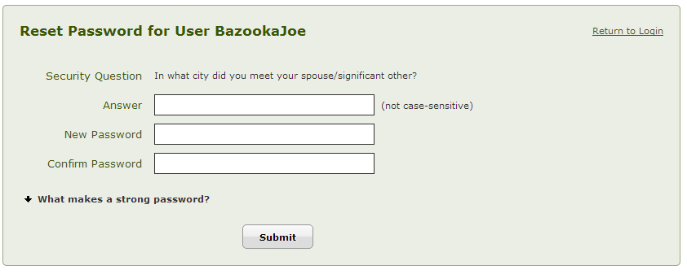

If the time limit has expired, the user will see the following screen and may restart the process by clicking the link.

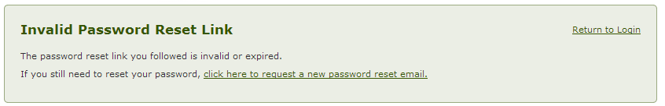

If the user has forgotten their username, has not answered security questions, or is an administrator, they will receive the following message. For security purposes, administrators must have another administrator manually reset their password using one of the options found in the “Password Management” section.

Note: although administrator accounts can be given the ability to perform a self-reset in system configuration settings, it is not recommended due to security considerations.

